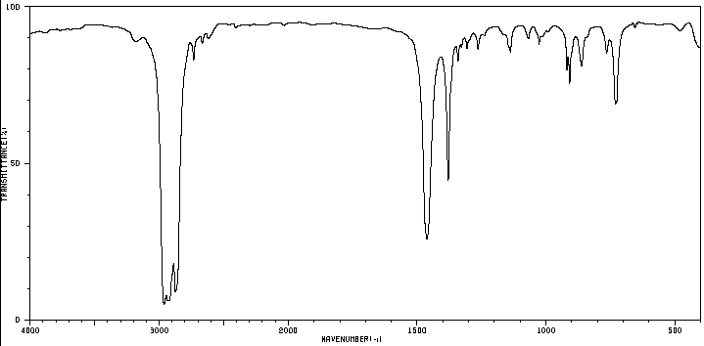
4000
3000
2000
1500
1000
500

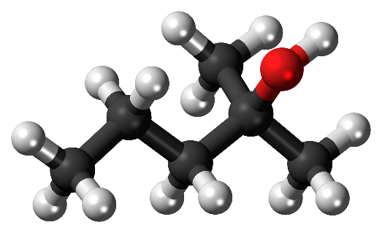

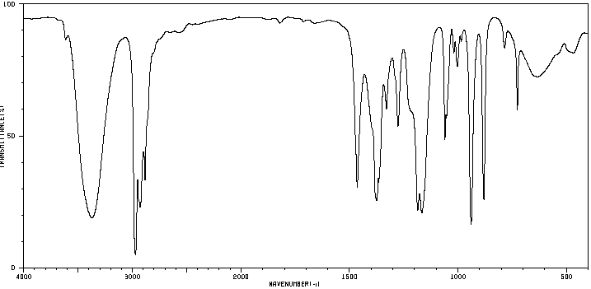
4000
3000
2000
1500
1000
500

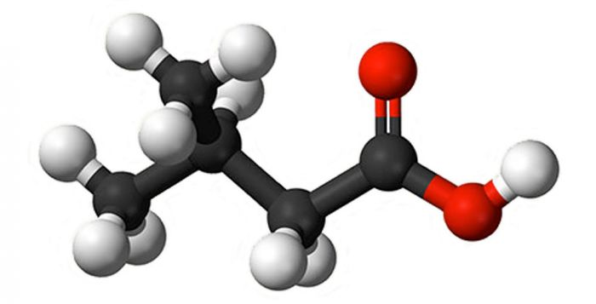

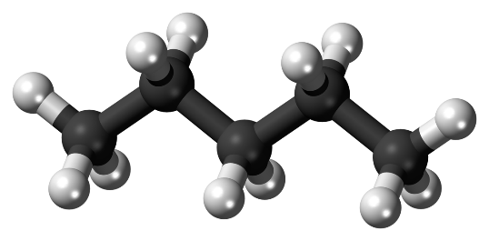

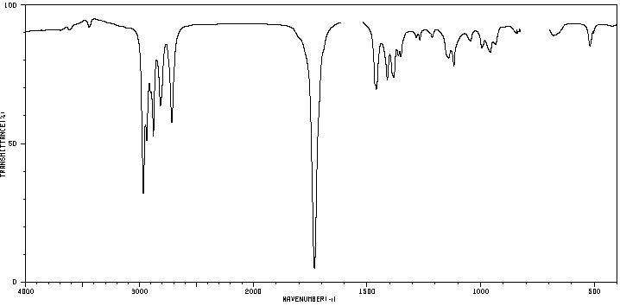
4000
3000
2000
1500
1000
500

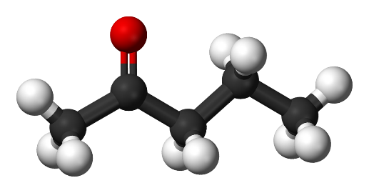

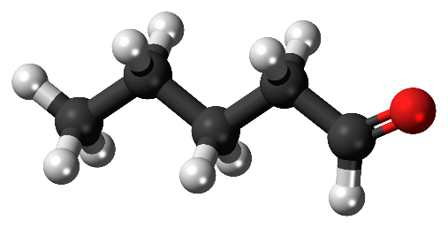

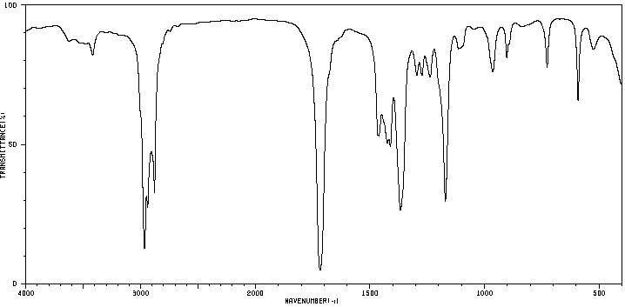
4000
3000
2000
1500
1000
500
4000
3000
2000
1500
1000
500

4000
3000
2000
1500
1000
500

4000
3000
2000
1500
1000
500

4000
3000
2000
1500
1000
500

